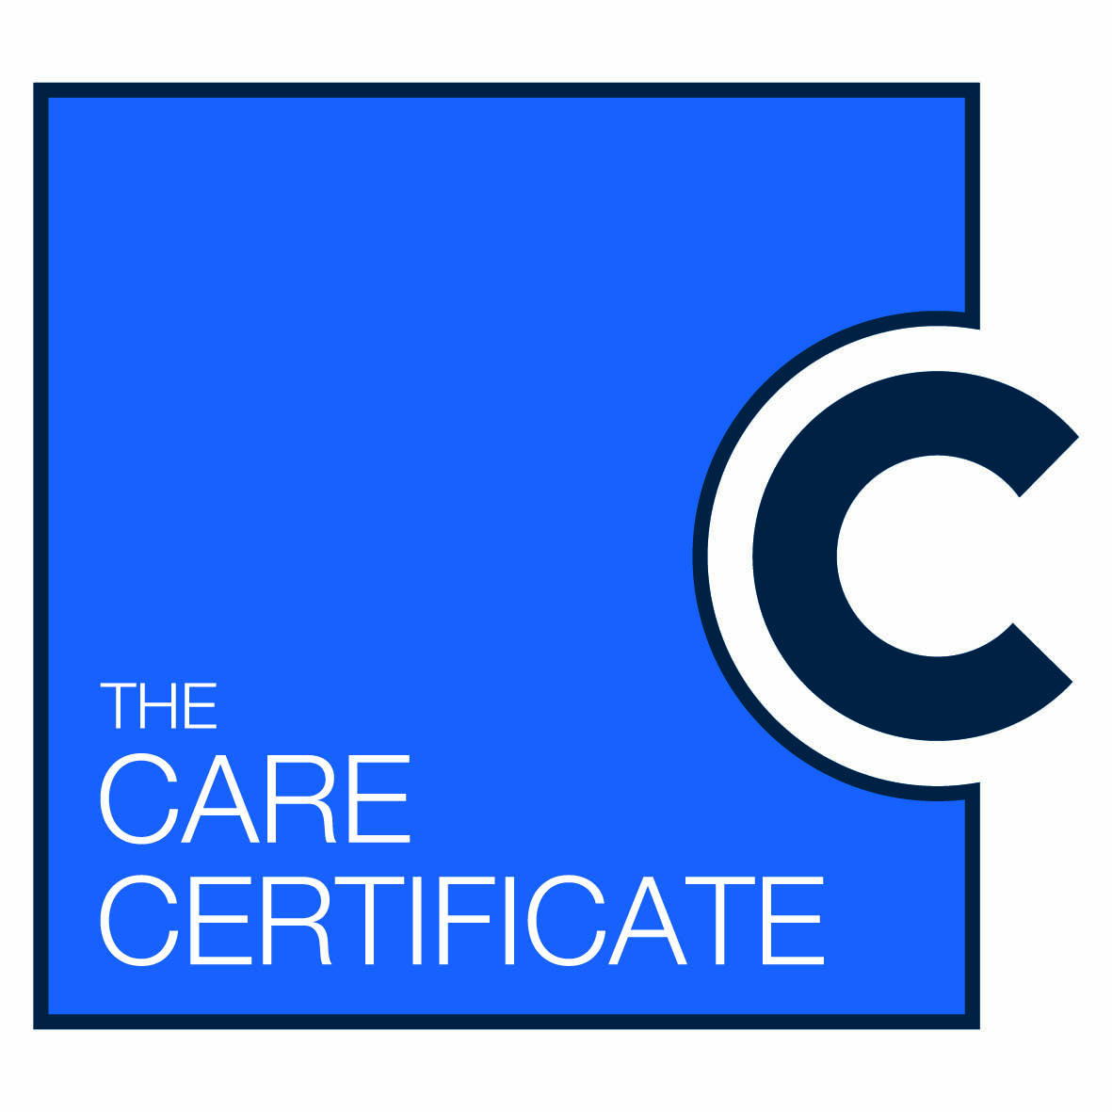
This certifies THAT

has been assessed as competent with Standard 6 of the Care Certificate based on the standards for Health Education England, Skills for Care and Skills for Health
Awarding Employer
Date of award

