Galaxy Mapping of Stakeholders
Time: ~20+ minutes
Materials: flipchart stand + flipchart pens; 1 x flipchart paper for each group.
Organise participants into groups based on their area. Depending on the number of participants you may want people to map out their local system and then join these up together to make a bigger star map.
Set-up. Give each group 1 x flipchart paper, post-its and pens. Colourful felt-tips work well for this. You can also use a Jamboard if you are working online.

Introduce the exercise: “The big idea with this exercise is to understand the galaxy in which you work. Working together as a group, map out your galaxy. These are the images we will use…”
Draw on a flipchart the images to use (search “galaxy doodles” or “space doodles” in google image search for ideas).
- Stars – these are the people or stakeholders in your galaxy. Some stars are closer together and some are further away.
- Some may be Bright stars (draw lines around the star to show it shining brightly).
- Stars connect together into constellations (draw lines to connect the stars).
This is the basic mapping. You may want to add in the other icons either now or when you go round the groups to check in with them:
- Shooting stars (or comets) are people who occasionally fly in and then fly out again.
- Satellites are part of your galaxy but not connected to anything.
- You may have some Black holes in your galaxy too and even some aliens (draw a UFO ship).
Top tip: leave it fairly open to interpretation as to these visual metaphors and feel free to add in more with the theme e.g., planets orbiting around a star, moons linked to planets, home planet etc.
Give the groups 10-15 minutes to work on their maps. Some groups may want to use post-its first before committing to paper.
Once groups have their galaxy maps get them to share back into the room. If there is a wall you could put them up on the wall and do a gallery walk style activity. Facilitator to scribe any questions or insights that come up from the whole room discussions.
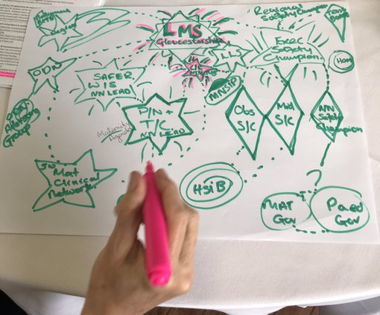
Galaxy map from one participant at a previous event

