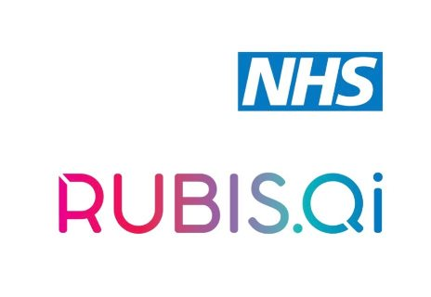

Adoption and Spread: Cohort 2

Application Form

Hello and thank you for applying to attend our Adoption and Spread course planned for June/July 2022. This will be our second cohort that is delivered in collaboration with Rubis.QI, following our successful first ever course in 2021. If you have any questions regarding the course please email weahsn.academy@nhs.net.

The application deadline is March 29th and successful applicants will hear from us on April 4th 2022.

About the course:
The workshops will be delivered online and have been deliberately designed to allow for group discussions, group activities and peer-to-peer coaching/support, enabling you to develop a rich and resourceful community.

The workshops will include a selection of case studies, theory and interactive activities to teach you the skills and capabilities needed for successful adoption and spread of your intervention/improvement. Using the latest thinking in healthcare adoption and spread, you will learn how to:

- choose an appropriate adoption and spread model
- understand what is core to your intervention/improvement
- lead adoption and spread
- evaluate its impact
- influence and engage others

Ideally delegates will come with an intervention/improvement idea they have tested and adapted using small scale testing and are now in a position to scale up/spread the intervention/improvement.

The course is free to attend and we ask you to commit to all the dates and times. We have a maximum of 25 places. You must have the support and commitment of your employing organisation and your line manager to release you to attend the dates already outlined.

Key Dates*

Workshop 1: Thursday June 9th 2022 (10:00-4.00pm)
Workshop 2: Thursday 23rd June 2022 (10:00-4.00pm)
Workshop 3: Thursday 7th July 2022 (10:00-1:00pm)

NB: Delegates must be able to attend and commit to all the above dates.

Please complete the details below and submit by Tuesday March 29th 2022 by midday to weahsn.academy@nhs.net.

Please note, when applying, you are agreeing to our delegate code of conduct.

Successful applicants will be notified of the outcome by email on the Monday April 4th 2022 and applicants should hold all workshop dates in their diary.

The criteria for selection are as follows:

- Demonstration of commitment to the adoption and spread of an idea, concept, way of working or product in their area of work
- Demonstration of how adoption and spread knowledge and skills will help you to progress your work
- Able to commit to the time requirements of the programme and have agreement from line manager to attend

Priority will be given to applicants who are currently leading work that is in the process of being adopted internally to a different part of the organisation or externally to other adopters.

If you’ve got an idea that you’d like to discuss with us before applying, please contact us on weahsn.academy@nhs.net

Personal Contact Details

Name:

Preferred Postal address:

We will be sending out a welcome pack to everyone on the course

Preferred Email address:

Job title:

Organisation:

Questions
1. What are your reasons for applying for the adoption and spread course at this time?

(Approx. 200 words)
2. Briefly tell us about the idea, concept, way of working or product that you hope that others will adopt.

(Approx. 200 words)

3. On a scale of 1-10, where 1 is ‘not yet ready for others to adopt’ and 10 is ‘fully ready for others to adopt’ how would you rate your readiness?

What would help you progress do you think?

(Approx. 200 words)

I confirm that I am available to attend all of the programme dates as outlined above and have full support from my line manager.

Name:

Date:

We’d like to stay in touch with you.

If I am successful in my application, I am happy to be contacted by the West of England AHSN when the course has finished to provide feedback to help improve the course for future cohorts.

If I am successful in my application, I am happy to have my contact details shared with my local improvement team (ICS, Trusts etc). I understand they might get in touch with me to offer follow up support to embed my learning.

Yes I’d like my data to be added to the AHSN database to I’d like to receive the monthly AHSN newsletter for the latest news and events.

We aim to eliminate any disadvantage based on age, disability, marriage or civil partnership, race, religion, sex, gender identity, sexual orientation, pregnancy, maternity, or any other characteristics. If we can make any adjustments let us know.

Thank you for applying to the West of England AHSN Academy course for Adoption and Spread. We value your interest and the time it has taken to apply. We will let you know the outcome of your application on April 4th. In the mean time, If you have any queries about the application process, please contact weahsn.academy@nhs.net

