[HOSPITAL ADDRESS]

Date: [DATE]

Sent via email
[CEO NAME]
[MEDICAL DIRECTOR NAME]

Dear [NAME] & [NAME]

The West of England Academic Health Science (AHSN) wrote to you in 2019 and earlier in 2021 to inform you about PreciSSIon, a collaborative project which aimed to reduce surgical site infection (SSI) after elective colorectal surgery across the West of England region.

The PreciSSIon project
Surgical Site Infection (SSI) is common after colorectal surgery where rates are reported to be as high as 30%. The aim of this project was to assess whether a collaborative approach to implement a new 4-point surgical care bundle could reduce SSI rates across seven hospitals in the West of England. Quality Improvement (QI) methodology based on the Institute for Healthcare Improvement’s Breakthrough Series collaborative model was used consisting of learning and sharing events with QI coaching. The Public Health England SSI surveillance questionnaire was used to measure patient-reported SSI at 30 days post-operatively.

An evidence based bundle of care was introduced including: 2% chlorhexidine skin preparation; dual ring wound protectors; triclosan-coated sutures for wound closure; and a second dose of antibiotics after four hours. Compliance with the bundle and questionnaire response rates were measured – watch this video to learn more about the project.

Celebrating success
We have worked as a collaborative including seven hospitals and the West of England AHSN from the project start in November 2019, and continued to meet online throughout 2020 and 2021 and have recently been celebrating our success in achieving our objectives. Across the region, we have halved SSI following elective colorectal surgery from a mean of 18% to 9.5%, and in our hospital we have reduced SSI from XX% to XX%.

Regionally, it’s estimated we have saved hospitals over £500,000 and prevented SSI in 103 patients. Read more here.

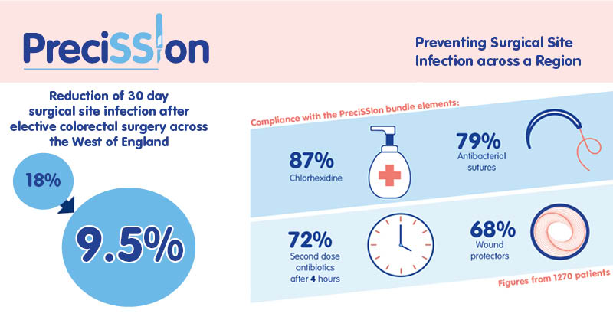

PreciSSIon has been shortlisted for two HSJ Patient Safety awards and submitted as an entry to the BMJ awards. The project has also been presented by members of the collaborative to the Association of Surgeons of Great Britain & Ireland, the Bristol Patient Safety Conference (and was chosen as the poster category winner), and the IHI & BMJ International Forum on Quality and Safety in Healthcare Europe 2021. A research paper has been submitted for publishing to the British Journal of Surgery, and our hospital’s contribution will be specifically credited.

We would like to thank you for supporting this work as the executive sponsor; we have made a real difference to patient care. We would welcome your continued support to keep this improvement sustained, and would like to present to you our hard work, achievements, and plans for sustainability. We would appreciate your consideration of the requests we may make to help enable us to continue reducing SSI rates in our hospital.

Yours sincerely,

The PreciSSIon team at [HOSPITAL]

[NAMES]

