PreciSSIon: a collaboration to reduce surgical site infection after elective colorectal surgery
BMJ awards application: Supporting information

Contents
1. Surgical wound healing questionnaire sent to patients 2
2. Surgical Site Infection (SSI) rate across hospitals 4
3. PreciSSIon bundle element compliance across hospitals 4
4. SPC chart 5
5. PreciSSIon toolkit 5
6. PreciSSIon promotional and feedback posters 6
7. PreciSSIon video for theatre nurses 8
8. Engagement with the PreciSSIon Collaborative 8
9. References 9

In collaboration with

1. Surgical wound healing questionnaire sent to patients

Surgical wound healing questionnaire

Dear Patient,

We are monitoring all patients with surgical wounds, to detect patients who develop wound infections after surgery.

We would be grateful if you could complete this questionnaire and return it in the pre-paid envelope.

Have you had any problems with the healing of your wound?

Yes [ ] Please continue with this questionnaire
No [ ] You do not need to continue with any further questions.

Did the problems with your wound arise when you were in hospital?

Yes [ ]
No [ ]

Since you were discharged from hospital after your operation have you noticed any of the following symptoms?

Has there been any discharge or leakage of fluid from any part of the wound?

Yes [ ]
No [ ]

If yes, was it either: Clear or blood stained [ ]
Yellow/green (pus) [ ]
Other – please specify__________________________

Please tick any of the following additional symptoms that applied to your wound:

Pain or soreness in addition to the discomfort experience
following the operation [ ]
Redness or inflammation spreading from the edges of the wound [ ]
The area around the wound felt warmer/hotter than the
surrounding skin [ ]
The area around the wound became swollen [ ]
The edges of any part of the wound separated or gaped open [ ]

Did any health care worker take a sample from your wound to send to the laboratory?

Yes [ ]
No [ ]

PLEASE TURN OVER

If you saw a health care worker because of these symptoms, please indicate who you saw from the list below –

GP [ ]
District Nurse [ ]
Midwife [ ]
Doctor or Nurse at the hospital [ ]
Other – please specify [ ]
Did not see anyone about my wound [ ]

Please tell us the date you noticed these symptoms.
If you cannot remember the exact date, please give an approximate date ___/___/___

Have you been prescribed antibiotics for an infection in the wound?

Yes [ ]
No [ ]
If yes, who prescribed them? _____________________________

Have you been readmitted to hospital with an infection of the surgical wound?

Yes [ ]
No [ ]
If yes, which hospital? _______________________________

Other comments ____________________________________________________________________________________________________________________________________________________________________________________

2. Surgical Site Infection (SSI) rate across hospitals
Average SSI rates before and after implementation of bundle for all hospitals. To note: Hospital 2 has had a 4% SSI rate since August 2020.
Hospital | Baseline SSI (no. patients) | Post bundle SSI (no. patients) | Response rate
1 | 15%(198) | 7% (187) | 74%
2 | 8% (128) | 8.6% (197) | 63%
3 | 22% (74) | 6% (136) | 100%
4 | 12% (44) | 8.5% (193) | 86%
5 | 30% (208) | 15% (175) | N/A
6 | 20% (197) | 11% (217) | 93%
7 | 20% (54) | 7% (42) | 68%
Mean all hospitals | 18% (903) | 9% (1147) | 81%

3. PreciSSIon bundle element compliance across hospitals
The table below shows compliance with each bundle element for each hospital. To note: Average compliance across the region is between 70% and 95% for each element of the PreciSSIon bundle. Some elements were easier to measure and some were easier to implement; for example it is not always possible to use a wound protector.
Hospital | Chlorhexidine | Antibacterial sutures | 2nd dose antibiotics after 4hrs | Wound protector
1 | 89% | 58% | 32% | 34%
2 | 91% | 68% | 34% | 33%
3 | 100% | 90% | 85% | 90%
4 | 84% | 86% | 98% | 83%
5 | 100% | 100% | 67% | 61%
6 | 100% | 100% | 100% | 91%
7 | 100% | 71% | 100% | 100%
Mean all hospitals | 95% | 82% | 73% | 70%

4. SPC chart
This chart demonstrates the decrease in combined SSI rates across the region following implementation of PreciSSIon bundle.

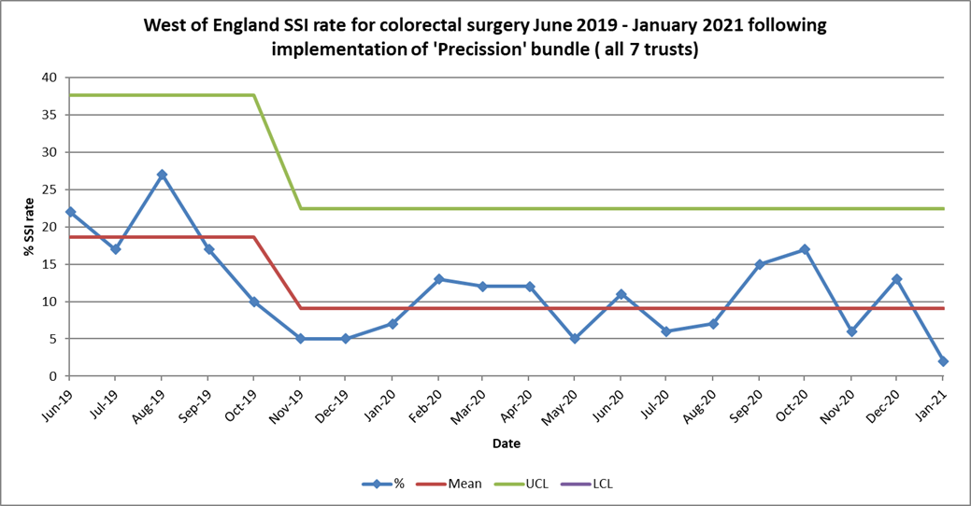
PreciSSIon implemented

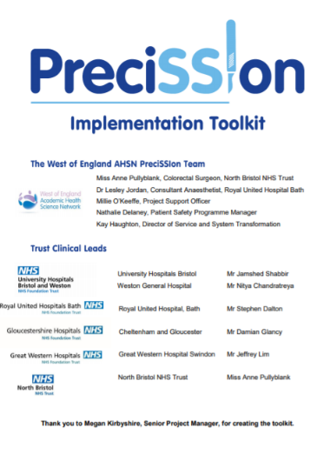
5. PreciSSIon toolkit

The toolkit was produced to support teams with implementing the bundle and data collection in their hospital teams.

The toolkit is available to download here: PreciSSIon-Implementation-Toolkit-v5.0.pdf (weahsn.net)

6. PreciSSIon promotional and feedback posters
Promotional posters for display in operating theatres and other areas were produced and shared with the collaborative, as well as editable posters to display data to encourage engagement with the project.

Example of poster feedback to individual hospitals showing improvements:
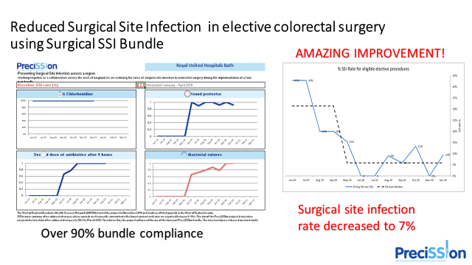

Twitter card celebrating the reduction in SSI rates and compliance figures across the West of England, April 2021:
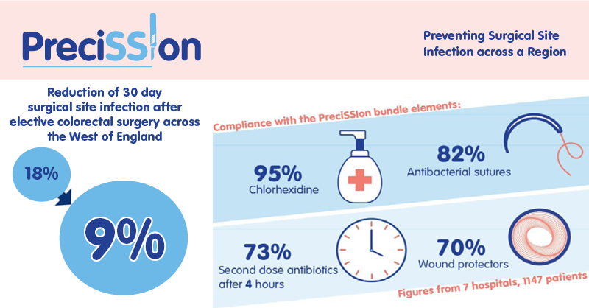

7. PreciSSIon video for theatre nurses
The video was created to explain how Theatre Nurses play a vital role in preventing SSI and how the PreciSSIon Bundle can help.
View the video here: https://vimeo.com/460466609 and a more generic ‘explainer’ video for the PreciSSIon project here: https://vimeo.com/463380575

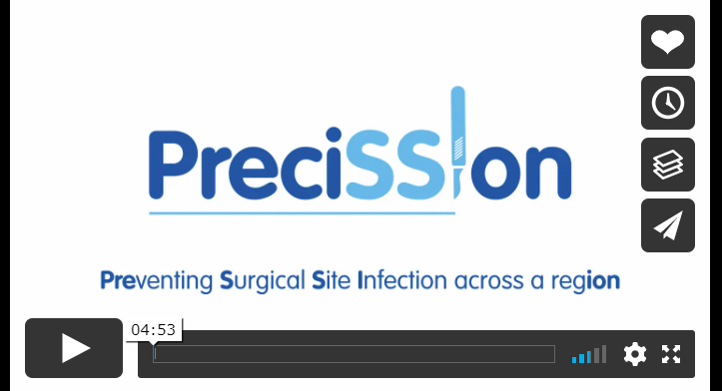

8. Engagement with the PreciSSIon Collaborative
A Tweet from a member of the collaborative celebrating the March 2021 PreciSSIon event.

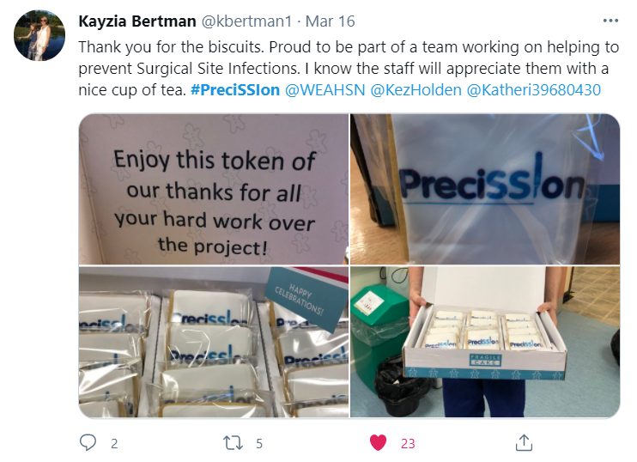

9. References
Morbidity associated with SSI

Wick EC, Shore AD, Hirose K, et al. Readmission Rates and Cost Following Colorectal Surgery. Dis Colon Rectum. 2011;54(12):1475-1479. doi:10.1097/DCR.0b013e31822ff8f0.

Sandy-Hodgetts K, Carville K, Leslie GD. Determining risk factors for surgical wound dehiscence: a literature review. Int Wound J. 2015;12(3):265-275. doi:10.1111/iwj.12088.
Itatsu K, Yokoyama Y, Sugawara G, et al. Incidence of and risk factors for incisional hernia after abdominal surgery. Br J Surg. 2014;101(11):1439-1447. doi:10.1002/bjs.9600.

Kirkland KB, Briggs JP, Trivette SL, Wilkinson WE, Sexton DJ. The Impact of Surgical-Site Infections in the 1990s: Attributable Mortality, Excess Length of Hospitalization, And Extra Costs. Infect Control Hosp Epidemiol. 1999;20(11):725-730. doi:10.1086/501572.

Astagneau P, Rioux C, Golliot F, Brücker G. Morbidity and mortality associated with surgical site infections: Results from the 1997-1999 INCISO surveillance. J Hosp Infect. 2001. doi:10.1053/jhin.2001.1003.

Nationally reported SSI data

Public Health England. Surveillance of Surgical Site Infections in NHS Hospitals in England: 2016 to 2017.; 2017. https://www.gov.uk/government/publications/surgical-site-infections-ssi-surveillance nhs-hospitals-in-england. Accessed November 26, 2018.

Public Health England. Surveillance of Surgical Site Infections in NHS Hospitals in England: April 2018 to March 2019, 2019 [07/05/2020]. Available from: https://assets.publishing.service.gov.uk/gover nment/ uploa ds/syste m/uploa ds/attac hment_data/file/85418 2/SSI_Annual_Report_2018_19.pdf

https://gettingitrightfirsttime.co.uk/

Surgical Site Infection rates with 30 day follow-up

Pinkney TD, Calvert M, Bartlett DC, Gheorghe A, Redman V, Dowswell G, et al. Impact of wound edge protection devices on surgical site infection after laparotomy: multicentre randomised controlled trial (ROSSINI Trial). BMJ 2013;347:f4305.

Blazeby J. Bluebelle pilot randomised controlled trial of three wound dressing strategies to reduce surgical site infection in primary surgical wounds. BMJ Open. 2020;10:e030615.
Limon E, Shaw E, Badia JM, Piriz M, Escofet R, Gudiol F, et al. Postdischarge surgical site infections after uncomplicated elective colorectal surgery: impact and risk factors. The experience of the
VINCat Program. J Hosp Infect. 2014;86:127–32.

50% of SSIs occur in the community
The community burden of surgical site infection following elective colorectal resection Lydia Newton1 | Ffion Dewi1 | Angus McNair2 | Dawn Gane1 | Jodie Rogers1 | Harry Dean1 | Anne Pullyblank1 DOI: 10.1111/codi.15420 Colorectal Disease. 2020;00:1–8.

The Evidence for implementing a bundle of care after elective colorectal surgery
H.F. Dean, E. King, D. Gane, D. Hocking, J. Rogers, A. Pullyblank. Introduction of a care bundle effectively and sustainably reduces patient-reported surgical site infection in patients undergoing colorectal surgery. Department of Colorectal Surgery, North Bristol NHS Trust, Bristol, UK Journal of Hospital Infection 105 (2020) 156e161

Effectiveness of care bundles in reducing SSI

Do surgical care bundles reduce the risk of surgical site infections in patients undergoing colorectal surgery? A systematic review and cohort meta-analysis of 8,515 patients Judith Tanner, PhD,a Wendy Padley, MSc,b Ojan Assadian, MD,c David Leaper, MD,c Martin Kiernan, MPH,d and Charles Edmiston, PhD,e Nottingham, Leicester, Huddersfield, and London, UK, and Milwaukee, WI http://dx.doi.org/10.1016/j.surg.2015.03.009 Surgery, Volume 158, Number 1; 66-77

World Health Organisation SSI Bundle in WHO Checklist
9. Haynes AB, Weiser TG, Berry WR, Lipsitz SR, Breizat A-HS, Dellinger EP, et al. A Surgical Safety Checklist to Reduce Morbidity and Mortality in a Global Population. N Engl J Med. 2009 Jan 29;360(5):491–9. 20. Weiser TG, Haynes AB, Dziekan G, Berry WR, Lipsitz SR, Gawande AA, et al.

Estimated costs of a SSI

www.gettingitrightfirsttime.co.uk/wp-content/uploads/2017/08/SSI-Report-GIRFT-APRIL19e-FINAL.pdf

Jenks PJ, Laurent M, McQuarry S, Watkins R. Clinical and economic burden of surgical site infection (SSI) and predicted financial consequences of elimination of SSI from an English hospital. J Hosp Infect. 2014;86(1):24-33. doi:10.1016/j.jhin.2013.09.012.

Guidelines on the prevention of surgical site infection
World Health Organization (WHO). Global Guidelines for the Prevention of Surgical Site Infection. 2016. 43.
National Institute for Health and Clinical Excellence (NICE). Surgical site infections: Prevention and treatment. NICE Guideline NG125. 2019.

