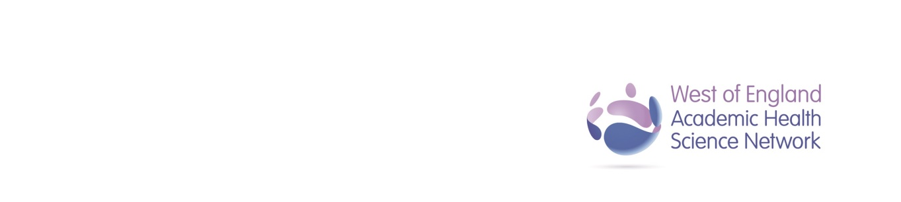

Documentation

Culture

Communications

Multidisciplinary Team

To reduce Emergency Department attendances by High Impact Users involved in this project by 20% and to improve the experience of High Impact Users and Emergency Department staff in one year.

**Primary Measures**

* Number of Emergency Department attendances in patients managed under High Impact User Team
* Number of admissions in patients managed under High Impact User Team
* Number of Personal Support Plans written

**Secondary Measures**

* Patient and staff experience
* Culture around High Impact Users in the Emergency Department

**SHarED Project Driver Diagram**

**Primary Drivers**

Processes

Training

Data collection

**Secondary Drivers**

**Aim**

**Measures**